**WASD – SOCIAL MEDIA FOR GAMERS**

*Sharan Sukesh*1, *Dhruv Dhawane*1, *Mokshik Trivedi*1, *and *Chinmay Raut*2

1Bachelor’s of Engineering (Computer Science), Universal College of Engineering, Kaman, Vasai, India

2Head of Department (), Universal College of Engineering, Kaman, Vasai, India

***Abstract :*** Online social games have become a major component in today's social media sites. The social networking sites environment has provided a platform for online games to develop and expand within the virtual medium. Users are now ready to play games online, compare scores, and challenge one another among many other things. thanks to the varied user demographics of social media sites, various motivations to playing social games emerge. the requirement for this present research was to answer the question whether the combination of social games within social networking sites and apps have increased the likelihood of playing those games. Therefore, the most objective of this research is to predict from the actual fact that may be wont to decide whether to incorporate games (Adventure, Fighting, Design\Art, Virtual Life…etc.) within the social media sites that also haven't been implemented (such as Twitter, Tumblr, etc.). Also, we would like to find whether the inclusion of social games has improved the services offered by social sites and whether social gaming has effects on human behaviour with regards to socializing and interacting with others. The aim of this study was to look at the relation between social media apps and games, and whether the previous has increased user's participation in online games. the first setting for the quantitative method of research study was the net gamers regardless their age, gender, and interests. the information were collected by distributing an internet survey, and were analysed using WEKA data processing tool. Two popular classification algorithms were wont to predict the solution of this research question. The resulting data were compared and tested for his or her accuracy using different metrics.

***Keywords*** : ***Social media, gaming, game, online gaming, discord***

**1. Introduction**

Water has flowed under the bridge since the very first research on video games and video gamers. Today every digital user could be a potential gamer (Brand, Lorentz, & Mathew, 2014). The social aspect of video games is brandished of the most reason for enjoying games. Alike other cultural object before, like novels, jazz, rock's’ roll music and television, video games were accused to be manifold types of devil products. This moral panic generated a good amount of labor on effects of video games and addiction to video gaming too. Lately, multi massively online games have worn the mask of Satan as their social feature represents now the main threat to video gamers’ well-being. Indeed, research demonstrated that social element of games intensifies playing activity (Haagsma, Pieterse, Peters, & King, 2013). Moreover, MMOs aren't only social but also endless, making them endlessly social (Wan & Chiou, 2006). The immersion of those online games is considerable (Snodgrass, Lacy, Francois Denga, & Fagan, 2011). These are the explanations for being the matter of todays as MMO games are ‘worse’ than the other game (Bernuy, Carbonell, & Griffiths, 2012).

**1.1 Motivation**

Gaming industry in general is worth much more in revenue than the global movie and North American sports industries combined. The video game industry has boomed in recent years because of the variety of ways to play games. In recent years online gaming has grown a lot it also got a boost from the lock down due to which the number of people engaged in this activity has increased exponentially. In this era of online gaming we have different platforms which provide users to express their skills in competitive and get famous, but these platforms are now overly saturated and are not based just around gaming Examples (You-tube, Twitch). We aim to provide a single platform only for people who are interested in playing in games and esports related content & we aim to solve one of the main problems in online gaming i.e. Toxicity. If you have ever played an online video game it's likely that you came across such a scenario, that the players in your team or the opponent team behave rudely. This effects the players mental health leading in depression. We provide a platform where 'Like Minded' players can come and interact with each other and build an online gaming community free of toxic behaviour. application can be made to tackle both the problems and make the process a lot cleaner and less hectic.

**1.2 Problem statement**

To build an application for gamers to reduce, Toxicity & Violence, Racial Stereotyping, Gender Stereotyping, Recognition for esports. There is no particular platform for showing individual skills so we want to provide one. As Pre-existing platforms overly saturated.

**2. Review of Literature**

Third, video gaming worlds together with virtual worlds provide a field for experimentation, a social field. This

playground has been taken by storm by players willing to adopt an identity they may not within the flesh world. Since the event of virtual worlds and video gaming worlds online, researches undertaken regularly illustrate this input for self-knowledge. With the utilization of NVivo Version X, posts were coded so as to spot the explanations for the gamer to say that this game saved their life. Three mains themes emerged from the analyses of discourses collected. Video gaming worlds provide a field for social experimentation and a social refuge. Plus, they enhance social bonding and connections. Into these themes we added sub categories to specific input of the sport into gamer’s life, Bear in mind that the main target is here on saving the gamer from something or someone. as an example, video games as a social refuge can even be an antidote for a harmful social environment.[1]

Social Refuge Among testimonies from gamers claiming that video games saved their life a recurrence quickly and strongly emerged. the bulk of stories related an enquiry for a sane social environment within which individuals would feel safe and secure. They explore for an antidote to their own social situation. effort from their close social environment might appear from an outsider point of regard an escapist behaviour. Yet, texts analysed clearly displayed stories of people searching for a social space answering their needs and expectations. Briefly gamers wanted to feel safe and secure during this social space where they chose to speculate their time.[2]

One of the explanations for this search was flying removed from a harmful social environment during which gamers don't enjoy being. the middle of the matter could either be reception or in school or at both. When being bullied in school, teenage-gamers foresee going back home and playing games so as to minimize their pain of being rejected by their peers. When living in a very household with abusive parents, teenage-gamers found joy, fun, and lightness in video gaming world environment. I don’t have many childhood memories aside from my parents fighting, and my NES system. Specifically, Tail Spin. I wouldn’t trade my NES memories for all the cash within the world. it had been my childhood. And a damn good one. Better than the one my parents would have given me had I not had a console to show to in life. Shannon, Teenager, Tail Spin, Fighting parents, problems with drugs or perhaps presence of folio among relations. Some noted case of parental divorce and therefore the resulting confusion following the separation from one parental figure. Chris and Michael explained how they were rejected by their family after their coming-is controlling and abusive for Jo.[3]

Gamers also testified deed from negative life experiences, like being cheated on by a partner or losing a detailed one. Few testimonies are from former soldiers back from Iraq trying to accommodate their new life situation while still back from Iraq and checking out that his girlfriend was cheating on him. Plus, Clark was actually deployed in Iraq and explained how gaming helped him to stay contact along with his friends whereas he was living a really different life. Serious illnesses were mentioned by gamers as an experience they struggle to forget by playing games[4].

prying the pain and diminishment of cancer treatment is one trigger for using video games as an antidote. The console soon clads to be a lifesaver Allyx Teenager, Cancer treatment, the loss of his grandmother has been brought because the reason for taking part in by TJ while full of a disease. Most of testimonies related depression symptoms and suicidal thoughts. Several gamers emphasized on the role of games in changing their ideas and attracting their attention to the sport rather than their problems. Daniel said that video games helped him staying concentrate on the now instead of concentrating on the past. Less dramatically, few gamers like Ashly claimed that video gaming leaded function of video gamers had already been notified and asserted. Here the seek for a supportive social environment where individuals interact safely is that the trigger for taking part in games. This unproven escapist action is, in reality, a healthy attitude. Players compensate when being in gaming worlds. Gaming worlds provide a social space sort of a shelter where gamers can save their social life. Testifiers also hide during this environment to remain socially busy at fewer costs than they might in an out-of-game environment.[5]

Online social games are becoming a significant component in today's social media sites. The aim of this study was to examine the relation between social media apps and games. The primary setting for the quantitative method of research study was the online gamers regardless of age, gender, and interests.[6]

**3. System Architecture**

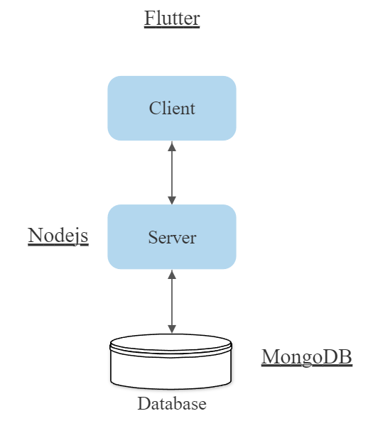

Figure 3.1: System Architecture

In WASD. App the client side (user) all the required data like email id, username, tags, interests and games played are taken. And stored In the database for further use. The data is then used to make a user profile based on the given details by user , the user can edit the given data in the profile whenever they want , then the user follows the top rated player or the suggested player and get the posts from them and can also access the news section. This is implemented by “Flutter” and stored in “Mongo Db”.

Now As the details are fulfilled by the user they can now successfully access the matchmaking system ,where they can set their preferences about the teammate they want ,and the for what game, then the SERVER Starts taking the data of the specific user and tries to match to the similar preference user, when the match is made then they procced to play that game.

The validity of the Gaming experience is then taken by the system and also the rating by which how much they like the game and how was the matchmaking, the can add each other as friends, and rate their profile by stars. Those stars are used to keep track of the particular user of is behaviour in game which improves his trust-factor and good rated profile.

**4. Requirements**

This section will provide the user the required specification of the hardware and software

components on which the proposed system is to be implemented

.

**Hardware Requirements**

This subsection will provide the minimum requirements that must be fulfilled by the

hardware components. The hardware requirements are as follows: -

• A smart phone with

1) Camera – minimum 5 megapixels

2) Storage – minimum 200 megabytes free

3) RAM – minimum 2 gigabytes

4) Processor – minimum dual core

• A desktop with

1) RAM – minimum 4 gigabytes

2) Storage – minimum 100 gigabytes

3) Processor – minimum quadcore or hexacore

**Software Requirements**

This subsection will provide the versions of software applications that must be installed. The software requirements are as follows: -

WASD App

Express.js

Nodejs

Mongo DB

Flutter

WASD App should be installed on the smartphone to use the features of this project.

Internet Connection

Mobile should be connected to the internet to make use of the app resources efficiently.

|  |  |  |
| --- | --- | --- |
| Parameter | Existing System | Social media for gamers |
| Support Platform | Only supports specific platform like only Xbox | Supports all platforms Xbox , ps4,ps5,Pc, mobile |
| Only mobile | Only for Mobile Gamers Was not up-to date only on website. | will be up to date and a mobile application |
| Location | Location specific – Only available in certain countries. | Will be available for India |

**5. Proposed System**

Table 5.1 Existing system versus proposed system

**6. Similar Projects**

Table 6.1Similar Projects.

|  |  |  |  |
| --- | --- | --- | --- |
| Sr  No. | Processed work | Findings | Year |
| 1 | Raptr was a social-networking website and instant messenger developed by Raptr, Inc. intended for use by video game players | Raptr | 2007 |
| 2 | A platform for mobile gamers to connect, join competitions, and stay updated with latest mobile gaming news/events. | Megplay | 2018 |
| 3 | eFuse is a web and mobile application for the Esports & Video Game industry. eFuse allows individuals to establish their gaming identity and participate in the industry at all levels. | E-fuse | 2018 |

Table 6.1 gives brief idea about some similar projects.

The system that is implemented helps the Community of gamers to grow themselves and know the upcoming games are trends in that field they can connect with the people of their same mindset. People can have teammates by searching in this app.

**7. GUI of Application**

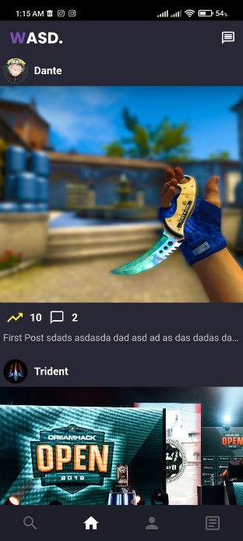

Figure 7.1: Shows the the home screen after login/register to the app.,where user can upvote and comment on the post.

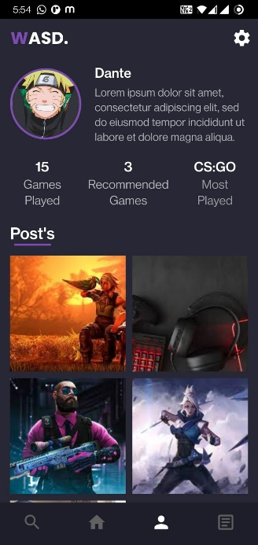

Figure 7.2: Shows the GUI of the the profile of the user ,having elements gathered by us and showing in the profile.

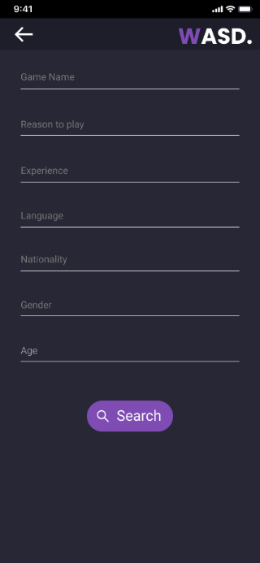

Figure 7.3: Then we have the Search Page, where user can search player’s, as per the requirements they fill.

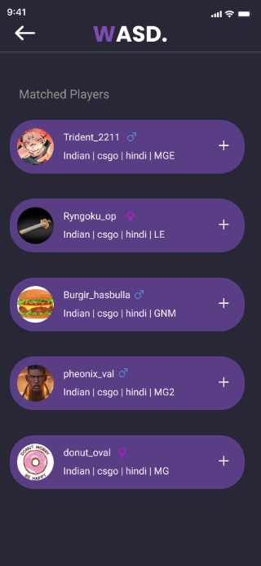

Figure 7.4: The result are shown up to the user.

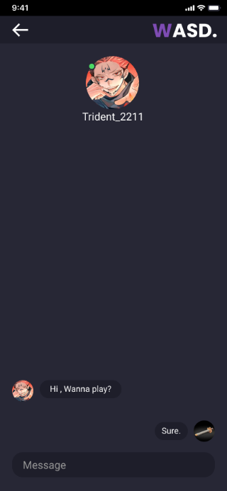

Figure 7.5: Then we have the home page where people can see the trending post and up-vote them.

**8. Conclusion and Future Plans**

The game industry has grown immensely within the last three decades and one major thrust has been social interaction among gamers offline and online. This paper presents an outline of the evolution of the gaming industry and therefore the different implementations of social channels in video games, the impact of integrating social media subsystems on gaming communities, their responses and feedback. Observations are made on the various trends in gaming in years between 1990 and 2019 and the way communication and social interaction affect players. Income models throughout the amount are explored.  
The study includes pursuit into some significant samples of the symbiotic relationship between social media platforms and also the gaming industry. Some examples are shown of the financial strength and revenue possibilities in gaming. As a result, it's concluded that gaming communities are strongly tied to the utilization of platforms, oriented towards social interaction outside of games.

**9.** **References**

[1]. Global social networks by users 2015 Statistic. (2015, August 1). Retrieved October 24, 2015, from

http://www.statista.com/statistics/272014/global-social-networks-ranked-by-numberof-users/

[2].Yee, N. (2006). Motivations for Play in Online Games. CyberPsychology & Behavior,9(6), 772-775. Retrieved October 24, 2015, From http://www.nickyee.co

m/pubs/ YeeMotivations (2006).pdf

[3]. Rossi, L. (2010). Playing Your Network : Gaming in Social Network Sites. SSRN Electronic Journal SSRN Journal. Retrieved October 24, 2015,

from http://sam.com/abstract-1722185

[4]. Ansari, N., Talreja, M., & Desai, V. (2012), “Data Mining in Online Social Games” . Retrieved October 20, 2015, from http://link.springer.com/chapter/10.1007/978-81-322-0740-5_95

[5]. Shin, D., & Shin Y. (2011). “Why do people play social network games? ”, Computers in Human Behavior, 852-861. Retrieved October 24, 2015, from <http://www.sciencedirect.com/science/article/pii/S0747563210003535>

[6] Aburahmah, Linah & AlRawi, Hajar & Izz, Yamamah & Syed, Liyakathunisa, “Online Social Gaming and Social Networking Sites”, Procedia Computer Science. (j.procs) , 2016.